**Project Planning Phase**

**Project Planning Template (Product Backlog, Sprint Planning, Stories, Story points)**

|  |  |
| --- | --- |
| Date | 27 July 2025 |
| Team ID | LTVIP2025TMID30362 |
| Project Name | Citizen AI – Intelligent Citizen Engagement Platform |
| Maximum Marks | 5 Marks |

**Product Backlog, Sprint Schedule, and Estimation (4 Marks)**

Use the below template to create product backlog and sprint schedule

| **Sprint** | **Functional Requirement (Epic)** | **User Story Number** | **User Story / Task** | **Story Points** | **Priority** | **Team Members** |
| --- | --- | --- | --- | --- | --- | --- |
| Sprint-1 | Registration | USN-1 | As a citizen, I can register on the platform with name, mobile, and Aadhaar number. | 2 | High | srilekha |
| Sprint-1 | Registration | USN-2 | As a citizen, I receive an SMS and email confirmation after registration | 1 | High | pranitha |
| Sprint-2 | Registration | USN-3 | As a citizen, I can register using my DigiLocker account. | 2 | Low | swetha |
| Sprint-1 | Registration | USN-4 | As an admin, I can approve or reject registration requests. | 2 | Medium | nitheesh |
| Sprint-1 | Login | USN-5 | As a citizen, I can log into the platform using mobile number and OTP. | 1 | High | pranitha |
| Sprint-1 | Dashboard | USN-6 | As a citizen, I can view a personalized dashboard with pending issues, alerts, and service requests. | 3 | High | srilekha |
|  |  |  |  |  |  |  |
|  |  |  |  |  |  |  |

**Project Tracker, Velocity & Burndown Chart: (4 Marks)**

| **Sprint** | **Total Story Points** | **Duration** | **Sprint Start Date** | **Sprint End Date (Planned)** | **Story Points Completed (as on Planned End Date)** | **Sprint Release Date (Actual)** |
| --- | --- | --- | --- | --- | --- | --- |
| Sprint-1 | 20 | 6 Days | 23 May 2025 | 25 May 2025 | 20 | 25 june 2025 |
| Sprint-2 | 20 | 6 Days | 23 May 2025 | 25 May 2025 | 17 | 26 june 2025 |
| Sprint-3 | 20 | 6 Days | 08 June 2025 | 12 june 2025 | 15 | 24 june 2025 |
| Sprint-4 | 20 | 6 Days | 14 June 2025 | 19 June 2025 | 18 | 25 june 2025 |
|  |  |  |  |  |  |  |
|  |  |  |  |  |  |  |
|  |  |  |  |  |  |  |
|  |  |  |  |  |  |  |

**Velocity:**

Imagine we have a 10-day sprint duration, and the velocity of the team is 20 (points per sprint). Let’s calculate the team’s average velocity (AV) per iteration unit (story points per day)

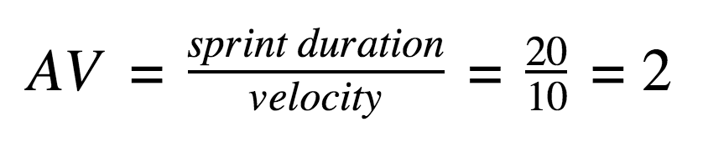

**Burndown Chart:**

A burn down chart is a graphical representation of work left to do versus time. It is often used in agile[software development](https://www.visual-paradigm.com/scrum/what-is-agile-software-development/) methodologies such as [Scrum](https://www.visual-paradigm.com/scrum/scrum-in-3-minutes/). However, burn down charts can be applied to any project containing measurable progress over time.